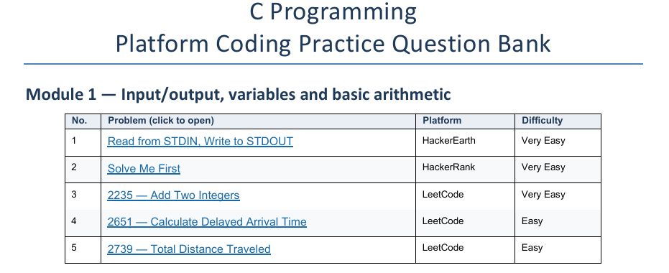

1 Read from STDIN, Write to STDOUT HackerEarth
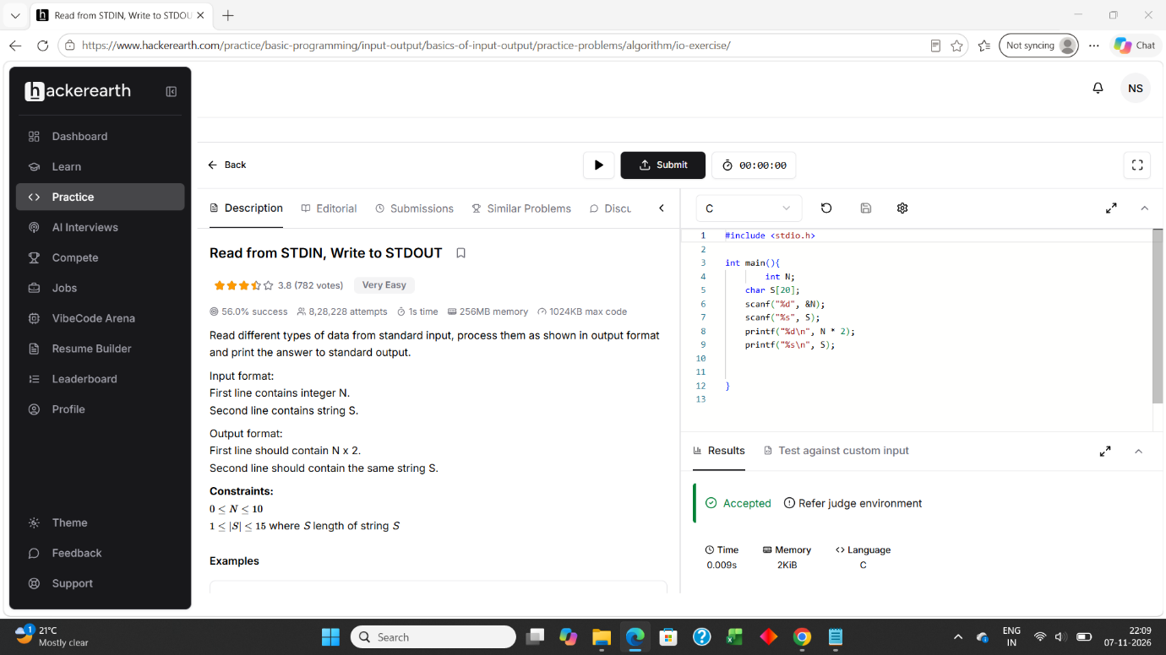

2 Solve Me First HackerRank

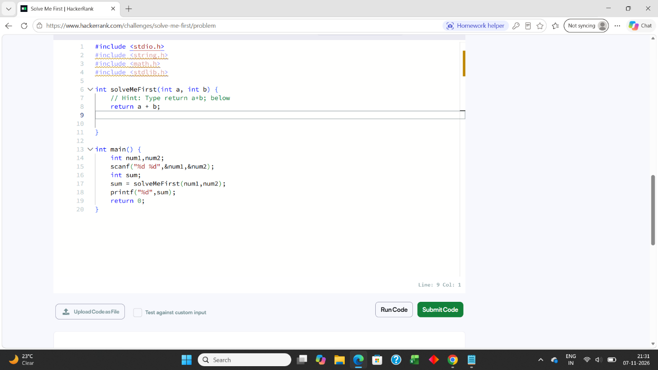

3 2235 — Add Two Integers LeetCode
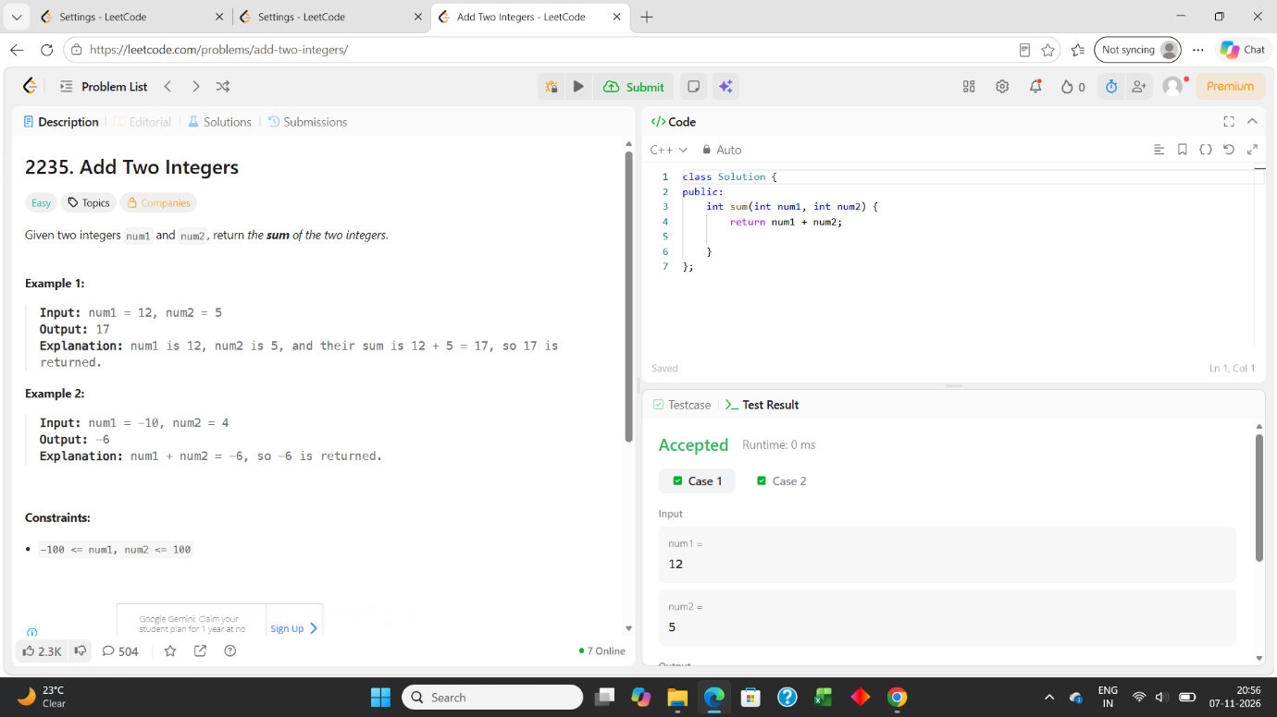

4 2651 — Calculate Delayed Arrival Time LeetCode
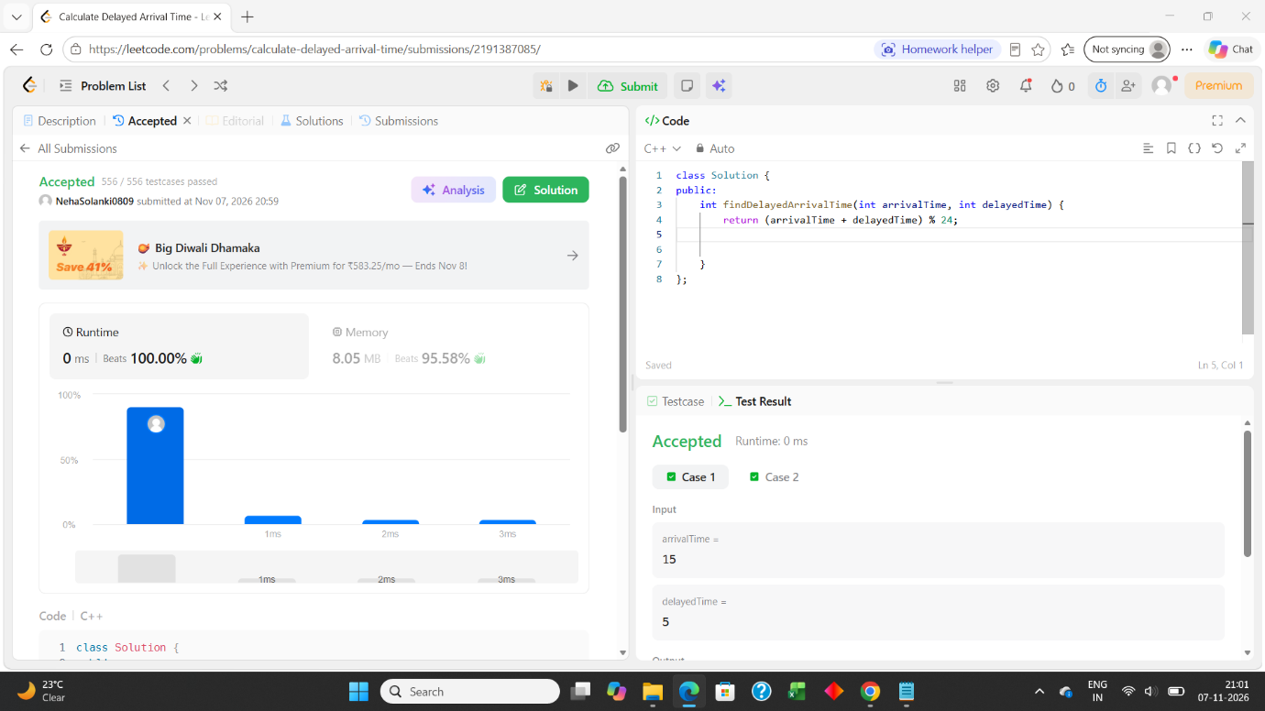

5 2739 — Total Distance Traveled LeetCode


